Lawrencia Agyemang
IDS 493
E-PORTFOLIO

REMIX #5

Old Dominion University
CYSE 270 Linux System for Cybersecurity
Assignment #2 Working on the Command Line

Lawrencia Agyemang
01085944

CYSE 270: Linux System for Cybersecurity

The goal of this lab is to help you install the three operating systems that you will use during the remainder of the labs.

Before the Lab – Required reading
Watch the course recording and complete the example practices
Task A Using Shell Features (5 * 20 = 100 points)
Step 1. Display your current directory.
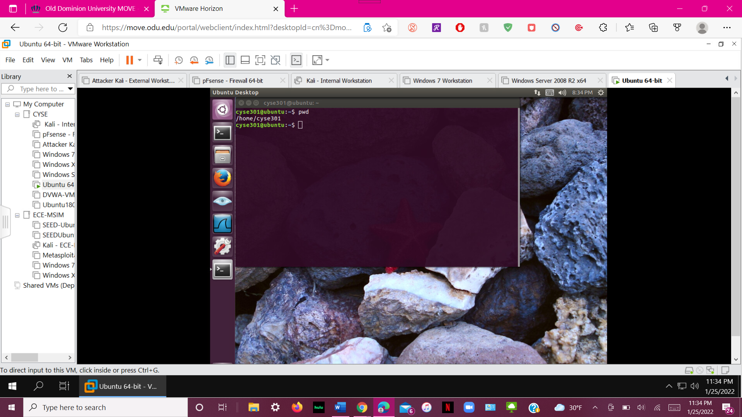
Here is my dictionary when I started.

Step 2. Using an absolute pathname, switch to the /etc directory.
Step 3. Using a relative pathname, move to the /etc/skel directory.
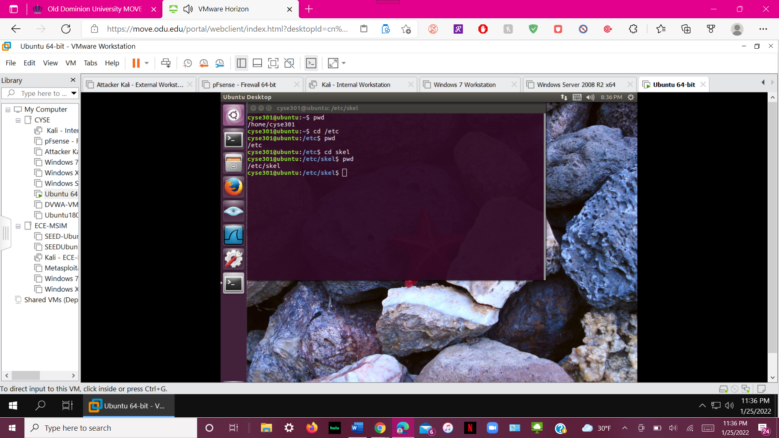
Above is the screenshot of steps 2-3 when I had entered in /etc and /etc/skel.
Step 4. Perform a “long display” listing of the files in the current directory.
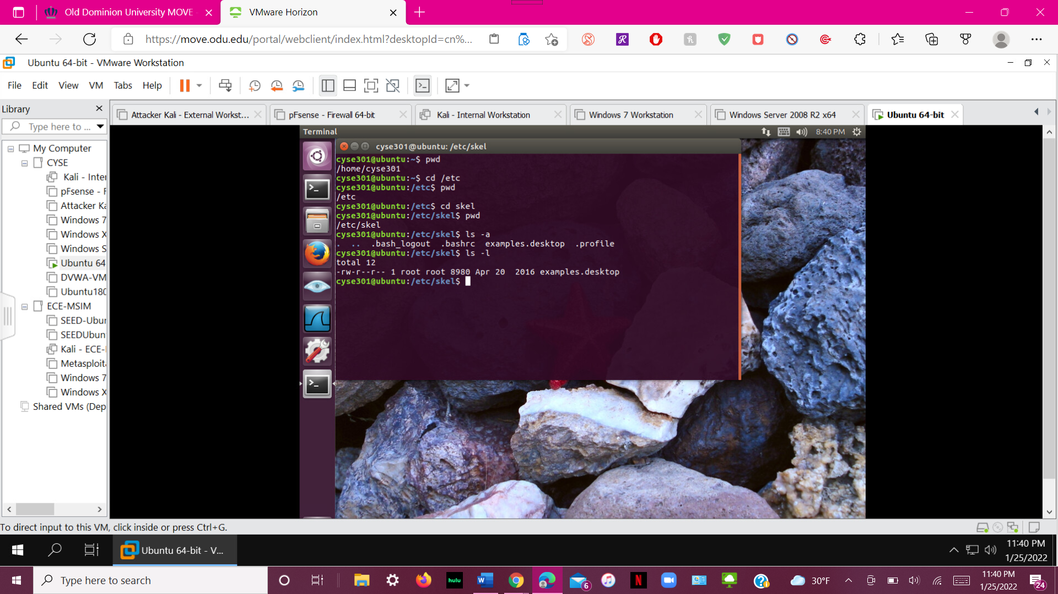
After getting the “long display” listing, my tis had a total of 12 files.

Step 5. Use relative pathname to move one folder above, then
Step 6. List all the files that begin with letter s.
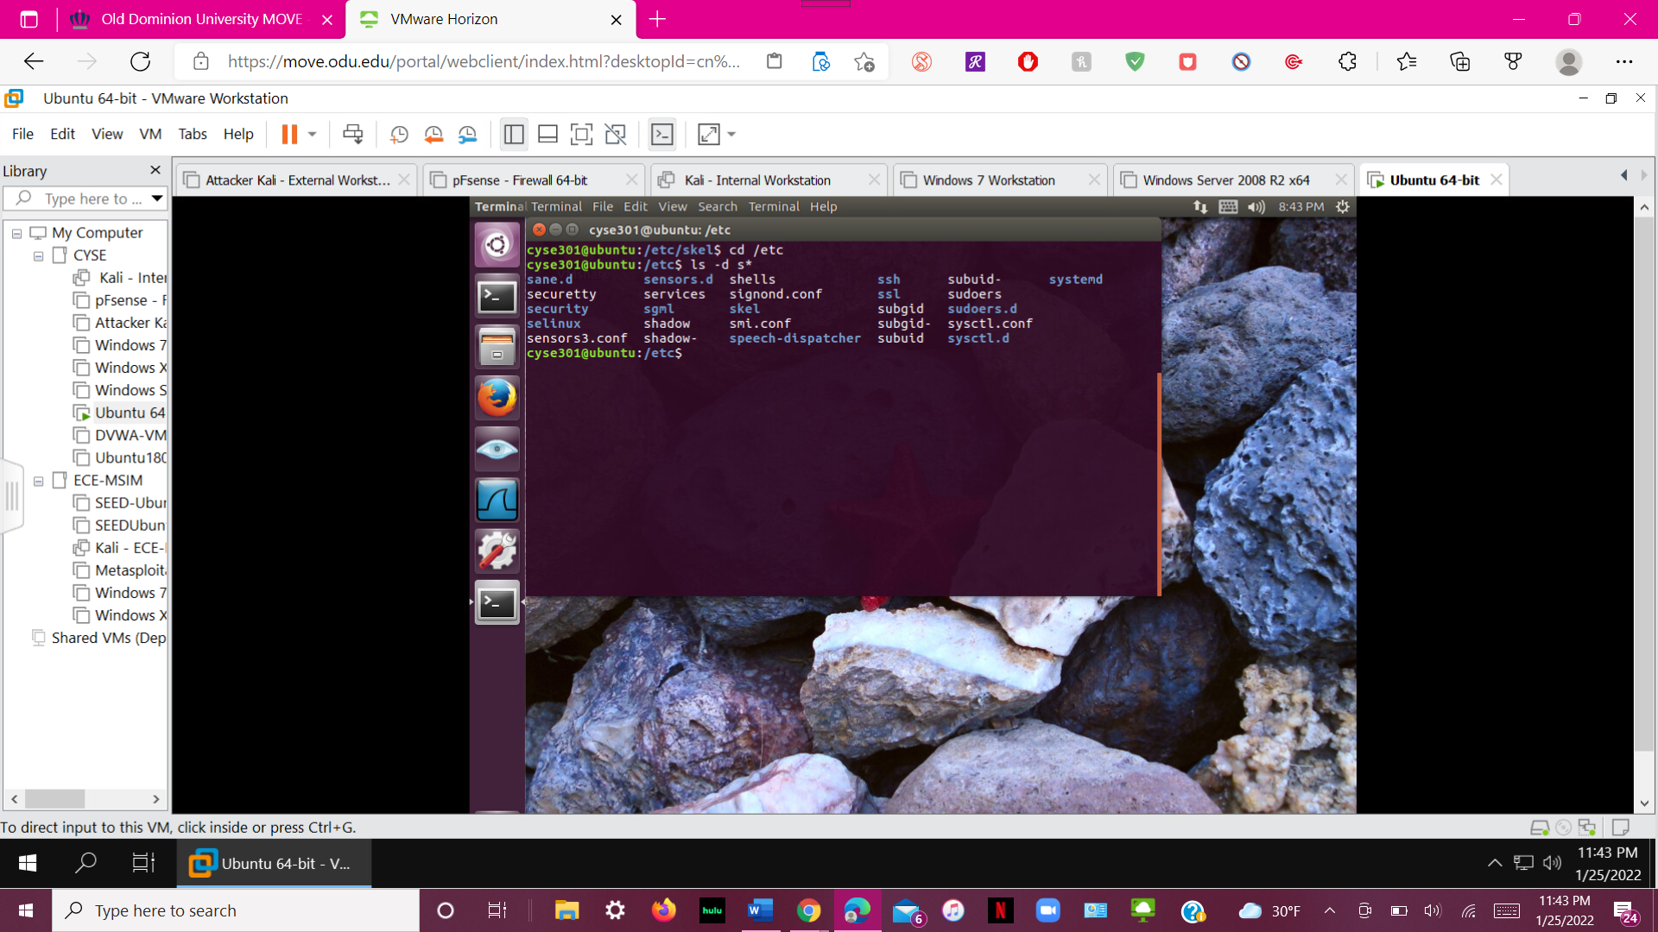
Screenshot for steps 5 and 6. Here is the list of files that start with the letter “s”

Step 7. Execute the command to return to your home directory.
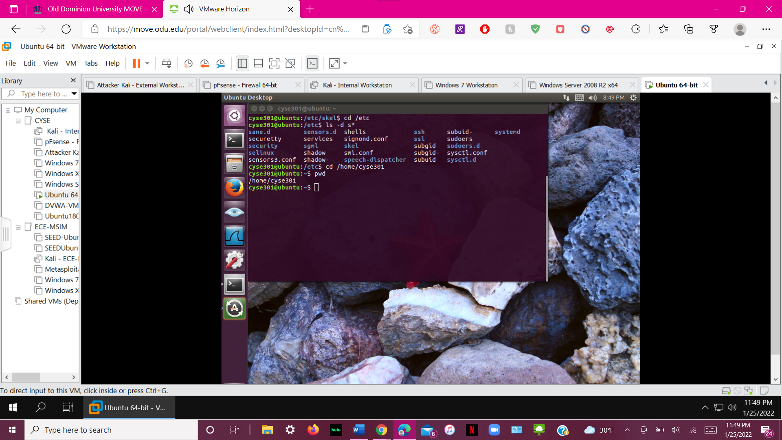
I entered my command in to take me to home. (it still cayse cyse301 because of I used it ODUmove last semester)
Step 8. Make a directory named “Your_MIDAS” in your home directory.
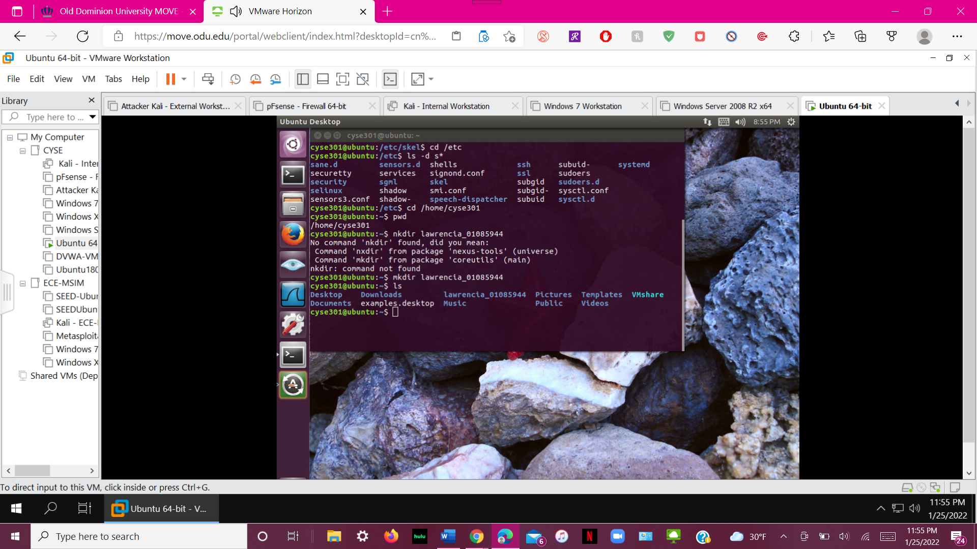
Named a file with my name and midas ID.
Step 9. Use two different approaches to copy the /etc/passwd file into the directory created in the previous step.
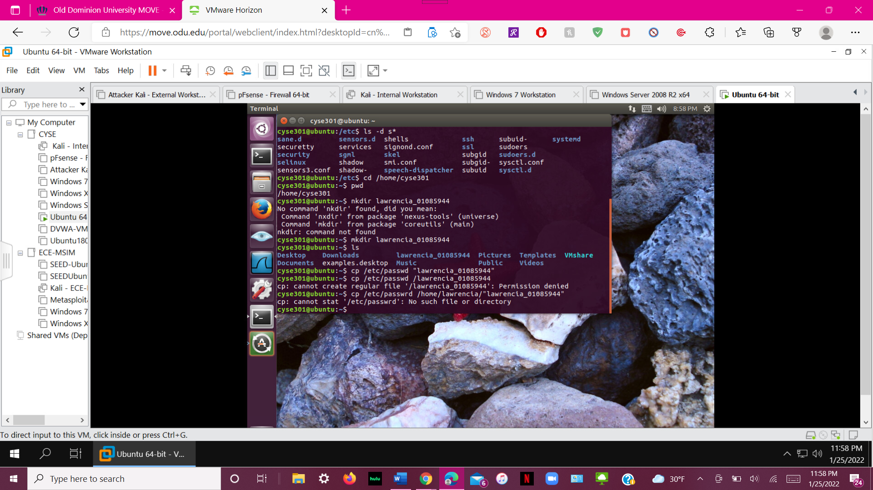
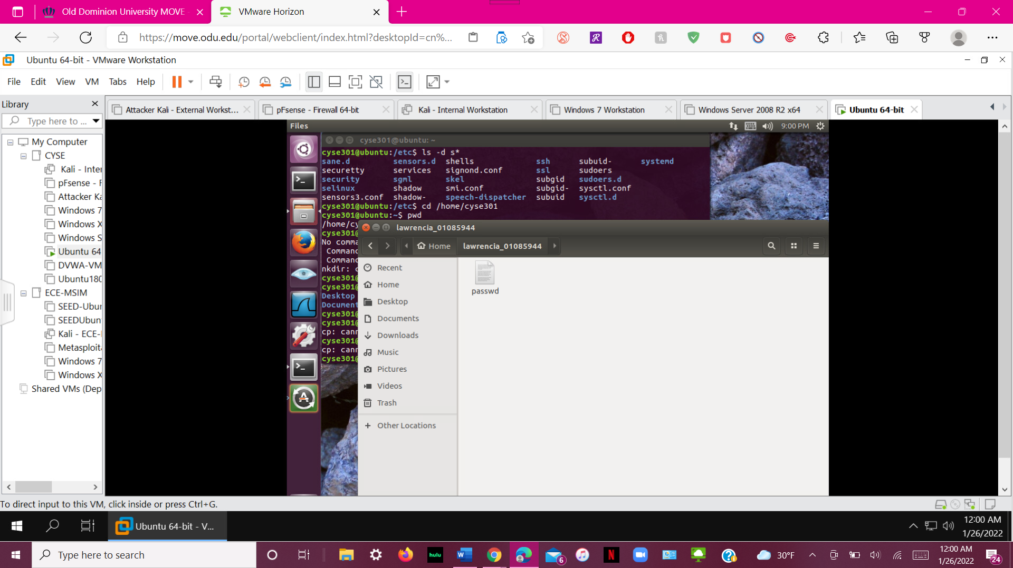

Step 10. Create a backup for the passwd file in the directory you created in Step 8 (use cp).
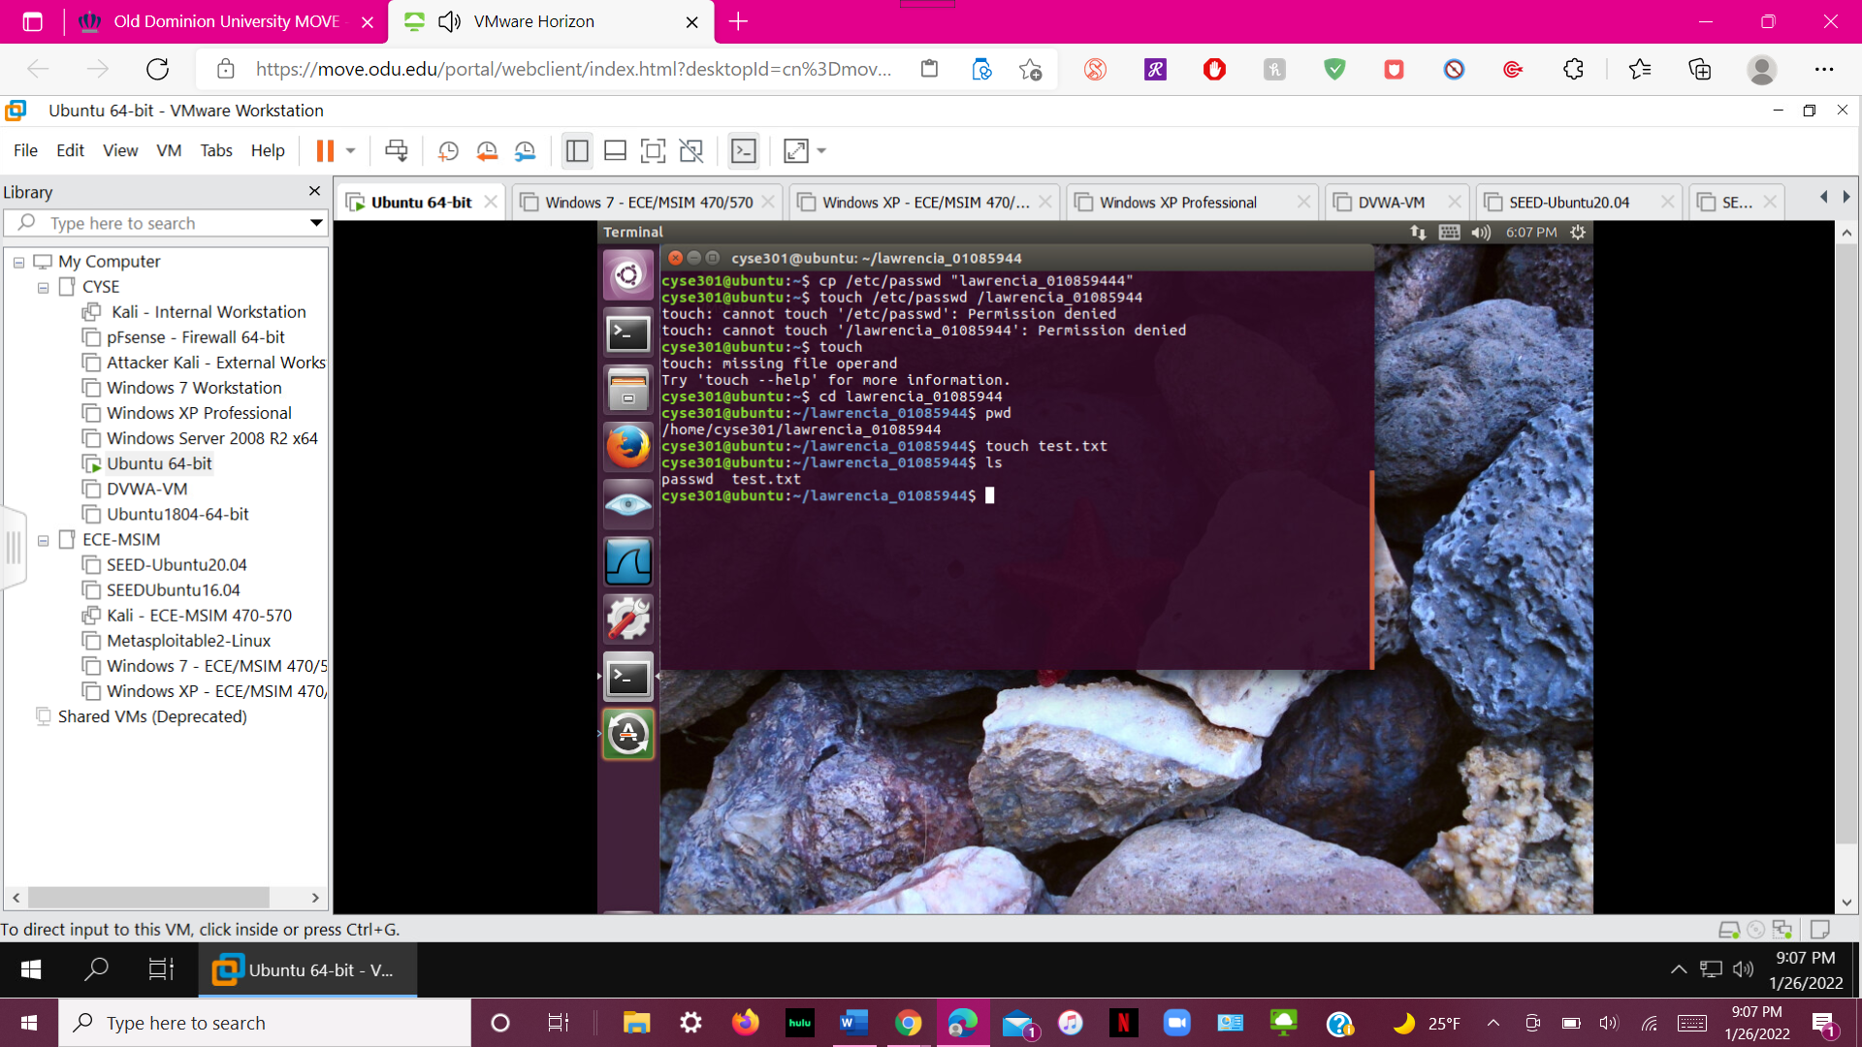
Step 11. Create a new empty file named test in the directory you created in Step 8.
Step 12. Rename the test file you created in Step 11 to TEST.
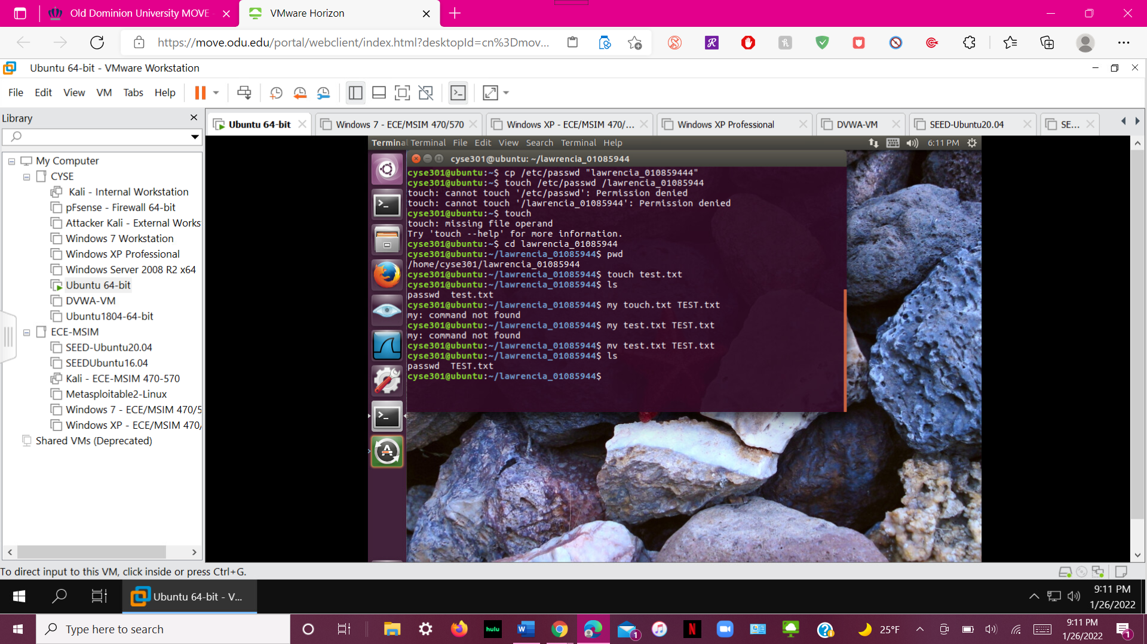

Step 13. Delete the TEST file.
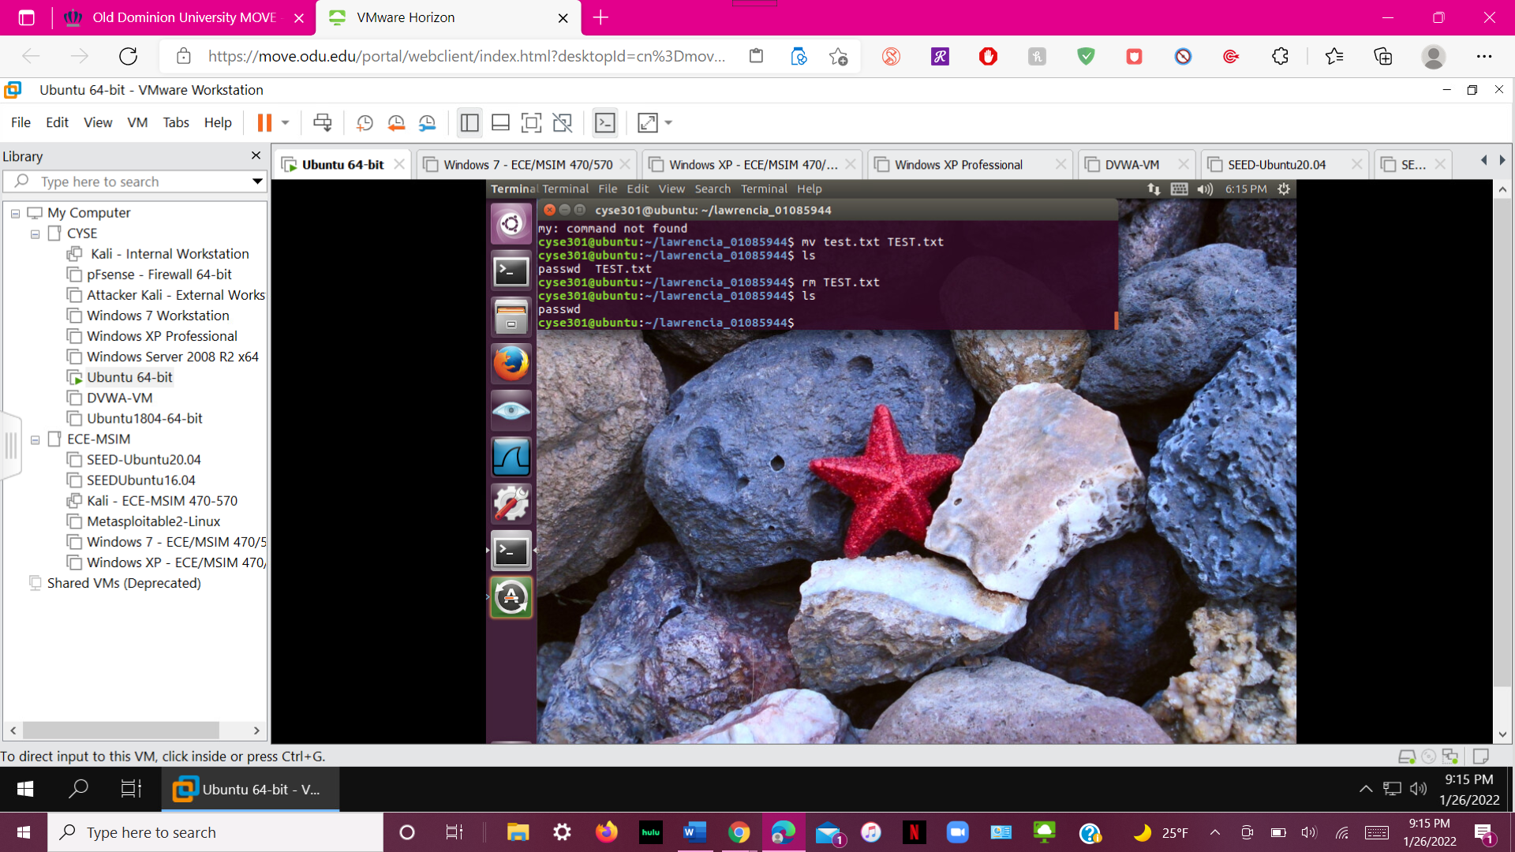
Step 14. Display only the last five lines of the /etc/group file.
Step 15. Run the command that will determine the type of contents in the /etc/group file.
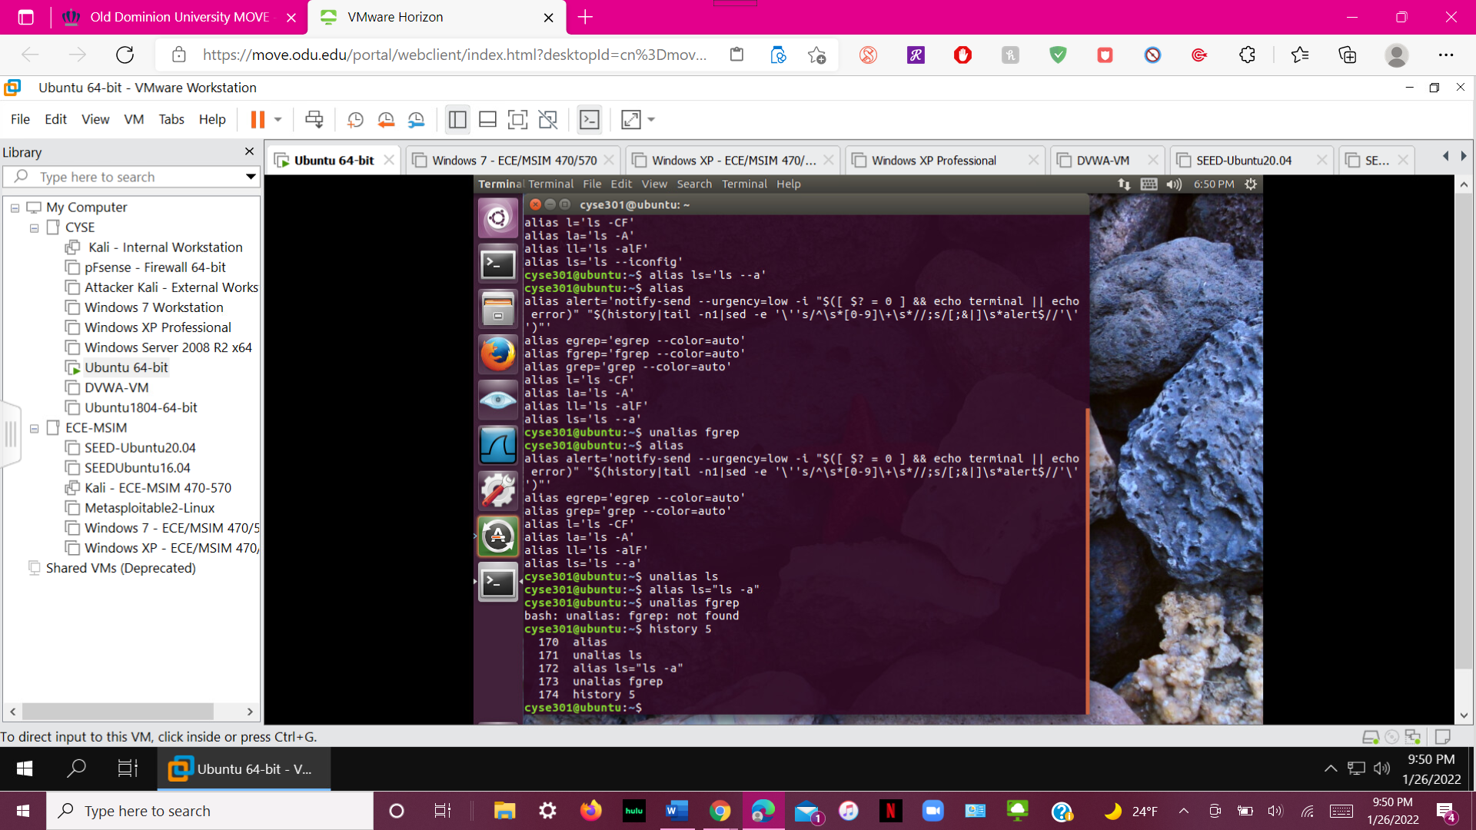
Step 14 and 15 with the last 5 files displayed at the bottom of the command screen.
Step 16. Display the first 5 lines of /etc/passwd file.
Step 17. Display the last 5 lines of /etc/passwd file.
Step 18. List the files and directories in reverse order by using the correct option with ls command.

Step 19. Display all the environment variables.

Step 20. Display the value of the HOME variable.
