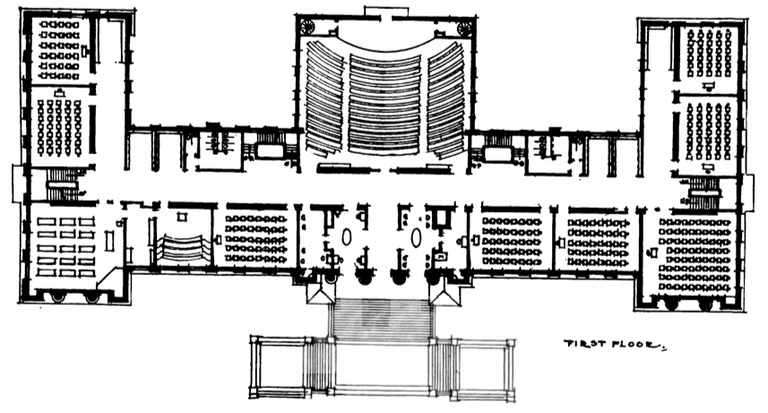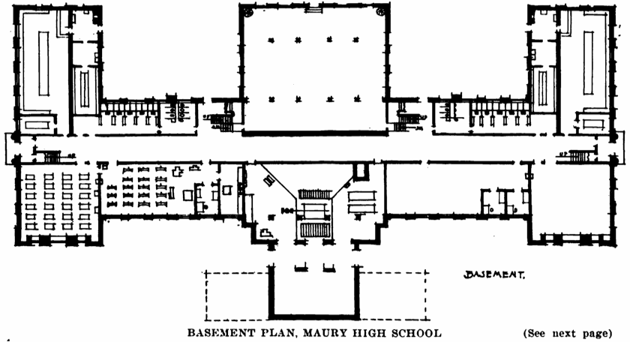

Telecomm Closet

Equipment Room

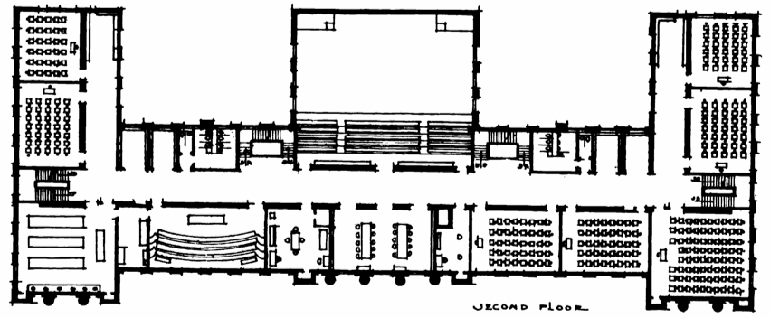

Telecomm Closet

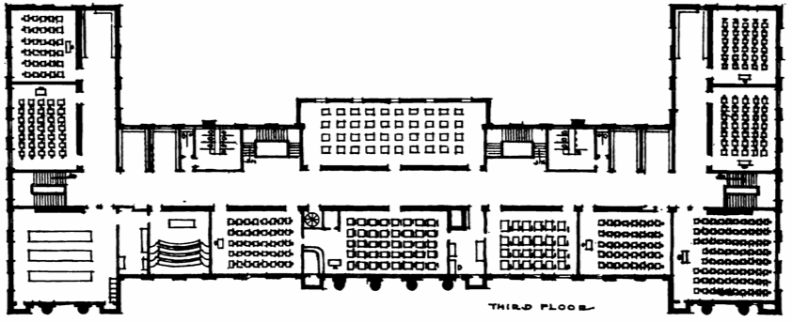

Telecomm Closet

Materials budget:

100 ft Cat6/5e cable: $14.84

[Cat6/5e Source](https://www.amazon.com/Mediabridge-Ethernet-Cable-100-Feet/dp/B003RCEAB8?ref_=Oct_BSellerC_9938477011_2&pf_rd_p=5c393220-1eff-5f3d-8077-b8ec5441d0fb&pf_rd_s=merchandised-search-6&pf_rd_t=101&pf_rd_i=9938477011&pf_rd_m=ATVPDKIKX0DER&pf_rd_r=Z0M9MVSQNCQJ1VD0KA5F&pf_rd_r=Z0M9MVSQNCQJ1VD0KA5F&pf_rd_p=5c393220-1eff-5f3d-8077-b8ec5441d0fb)

* 6388.54 meters = 20959.77 Feet
* 20959.8 ft/100ft = 210 cables
* 210*14.84= $3116.4

Cat5e wall plate: $7.99

[Cat5e wall plate Source](https://www.amazon.com/IBL-1-Cat5e-keystone-Ethernet-Gold-plated/dp/B01KDM08SI/ref=sr_1_1_sspa?crid=1MPMSWQVXR2YS&keywords=cat5e+wall+plate&qid=1556566493&s=electronics&sprefix=cat+5e+wall%2Celectronics%2C140&sr=1-1-spons&psc=1)

* Total: 174 outlets* 7.99 = $1392.26

48 port patch panel: 109.81

[Patch panel source](https://www.newegg.com/Product/Product.aspx?Item=9SIA6ZP8WR3449&Description=patch%20panel&cm_re=patch_panel-_-12-998-072-_-Product)

* 174 cables /48 ports = 3.63 patch panels
* 4 panels* 109.81 = $439.24

In telecomm closets:

48 port managed switch: $369.99

[Switch source](https://www.newegg.com/Product/Product.aspx?Item=9SIA6ZP3K24991&Description=managed%20switch&cm_re=managed_switch-_-33-310-430-_-Product)

* [174+(174*.10)]=191.4 outlets
* 191.4/48= 3.98
* 4 switches * 369.99= $1479.96

In equipment room and telecomm closets:

Triband Router $210

[Router source](https://www.newegg.com/Product/Product.aspx?Item=9SIACVB95S8589&Description=router&cm_re=router-_-33-320-218-_-Product)

3 rooms = $630

Total cable estimate:

The basement has 25 rooms and would need 50 cables and outlets

* Shortest cable distance: 5 meters
* Longest cable distance: 63 meters
* Average: 34 meters
* 50*34 = 1700meters of cable

1st floor has 19 rooms and would need 38 cables and outlets

* Shortest cable distance: 2 meters
* Longest cable distance: 79 meters
* Average: 40.5 meters
* 38*40.5 = 1539 meters of cable

2nd floor has 22 rooms and would need 44 cables and outlets

* Shortest cable distance: 2 meters
* Longest cable distance: 71.25 meters
* Average: 36.62 meters
* 44*36.62 = 1611.5 meters of cable

3rd floor has 21 rooms and would need 42 cables and outlets

* Shortest cable distance: 2 meters
* Longest cable distance: 71.25 meters
* Average: 36.62 meters
* 42*36.62 = 1538.04 meters of cable

Grand total of 6388.54 meters of cable for all 4 floors

Network Diagram

100 Staff Workstations

100 Student Workstations

100 Student Workstations

Switch

10.0.1.1

Router

Switch

10.0.2.2

Switch

10.0.2.1

Switch

Router