Clinical Log 1 Name: Keren Eicher

Volunteer Hours:
June 3: 9:15-14:00= 4 hr 45 min
June 8: 09:00-16:25= 7 hr 25 min
June 9: 0900-13:30= 4 hr 30 min
Total: 16 hours 40 minutes
Activities during this time: Checking patients into the clinic, obtaining vitals, drawing lab work when ordered, and collaborating with providers regarding patients who needed additional tests.
I was confident in all the activities I did, as I work at another free clinic regularly. I took time to listen to the patients and make sure I understood them. I was proactive in recognizing abnormalities in patients. One day, I noticed a patient seemed to be in alcohol withdrawal, so I immediately got the provider to come into the exam room. It turned out that the patient was in withdrawal, so emergency services were called. A few weaknesses/areas for improvement are that I sometimes get flustered rather than staying calm when I have a line of patients waiting on me, though I have been working on that. I was also not familiar with the clinic, so it took more time to figure things out and find everything I/the patients needed. During these volunteer hours, I learned how to do an ECG and breath tests. I learned that if someone has high cholesterol, the serum in a gel tube appears cloudy rather than clear. I also learned how to collaborate more effectively among all the clinic staff.
1.Give a brief overview of your community partner site and the community members you have been working with.
The community partner site I volunteered at is the Orange Free Clinic. This clinic serves the underserved population of Orange County, who are unable to afford healthcare services.
The members working at the clinic include two nurse practitioners, two receptionists, a Spanish translator, and a pharmacy technician.
Most of the patients at the clinic are American, African American, or Hispanic. Many are below the poverty level.

2.Create an Empathy Map- Empathy maps are designed to help you connect with the needs of your community members and groups. Use the prompts to get you started, feel free to add more.

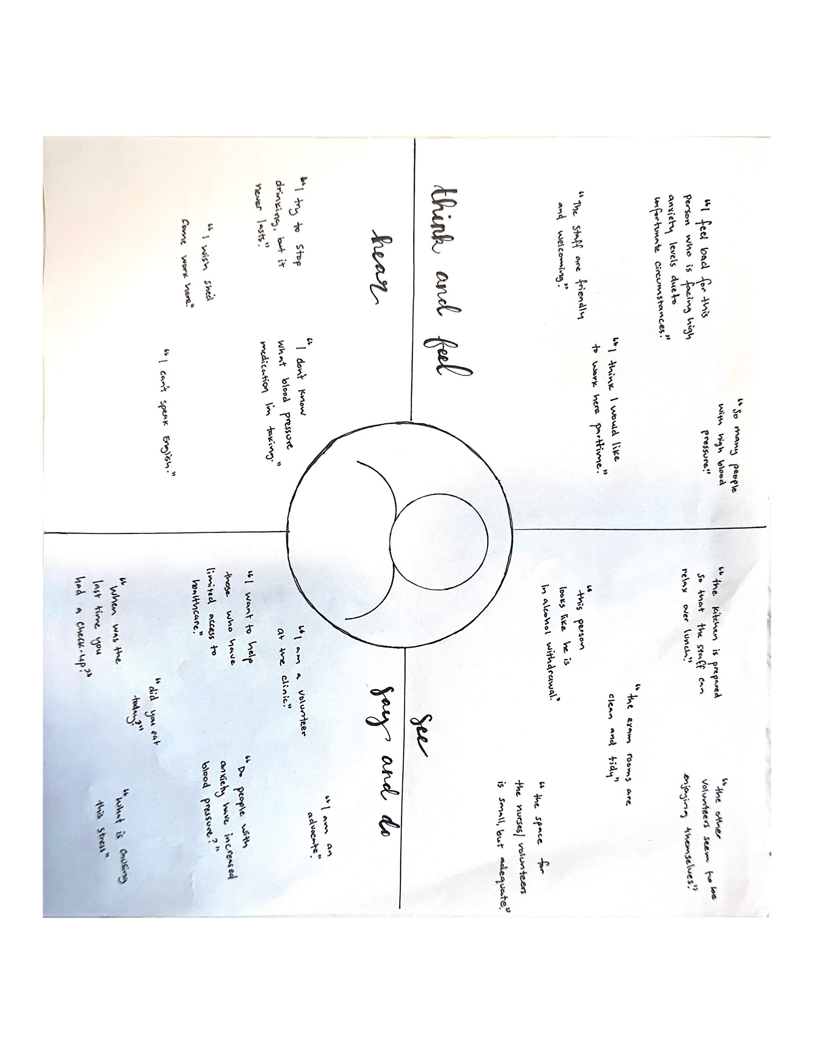
- Reflect on how community health is impacted as it related to the people served by your community agency site. What are the aggregate population experiencing?
The aggregate population is experiencing hardships, such as divorces, unemployment, and deaths, that are leading to high stress and anxiety levels. This leads to increased alcohol consumption and the use of drugs to try to escape from reality. Many patients also presented with diabetes, high blood pressure, pain in various parts of the body, and kidney issues.

- What is the role of the nurse as it related to the health of this aggregate population? Explain.
The role of the nurse is to provide empathy and a non-judgmental attitude when presented with the hardships patients are experiencing. The nurse should also educate patients about screening for high blood pressure and sugar and assess risk factors for these issues. If patients present to the clinic already diagnosed with these issues, the nurse should assess the extent of the issues, draw labs as ordered by the provider, and educate patients on management strategies.

- Think about the public education needs that either target your aggregate OR the public at large. Tell me about who you think needs increased awareness, education, or resources. You can include information from Healthy People 2030 here.
Those who need increased education on hypertension are adults over 18, obese individuals, those with a family history of high blood pressure, those who have limited access to healthcare, and ethnic groups who have a higher rate of hypertension. According to the Office of Disease Prevention and Health Promotion (2023), the proportion of adults with high blood pressure decreased only slightly from baseline, from 45% in 2017 to 44.1% in 2023. This indicates a need for increased hypertension awareness among adults.

- Create a SMART objective that will guide your health campaign

S – Specific. Succinctly state what you shared as the need in #5
M-Measurable. How could you measure the campaign in short and long term? How will you measure the process of implementing the intervention?
A-Achievable. What is an achievable version of what you would like to create. What resources do you need
R-Realistic or Relevant- Is your topic relevant to your target audience. What is your timeline?
T-Time- When will the intervention occur? How much time do you need to implement your intervention? When can you expect results?

Specific: My campaign will increase hypertension awareness and treatment among those with limited access to healthcare.
Measurable: Short-term: by the end of the campaign, 75% of participants will show an increase in hypertension awareness. Long-term: within 6 months, there will be a 20% decrease in hypertension rates within my targeted population.
Achievable: I want to use surveys and a PowerPoint slide in my campaign. For this, I need my computer, time, and reputable sources that back up my information.
Realistic: Yes, this topic is relevant to my targeted population, as many people show a lack of hypertension awareness. My timeline is the end of this semester.
Time: The intervention will occur this semester. I need a few days to implement my intervention. I can see short-term results from surveys on the day of the campaign and long-term results on hypertension rates by 6 months.

References
Office of Disease Prevention and Health Promotion. (2023). Reduce the proportion of adults with high blood pressure — HDS-04 . Healthy People 2030. https://odphp.health.gov/healthypeople/objectives-and-data/browse-objectives/heart-disease-and-stroke/reduce-proportion-adults-high-blood-pressure-hds-04

