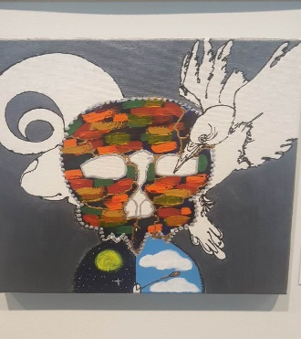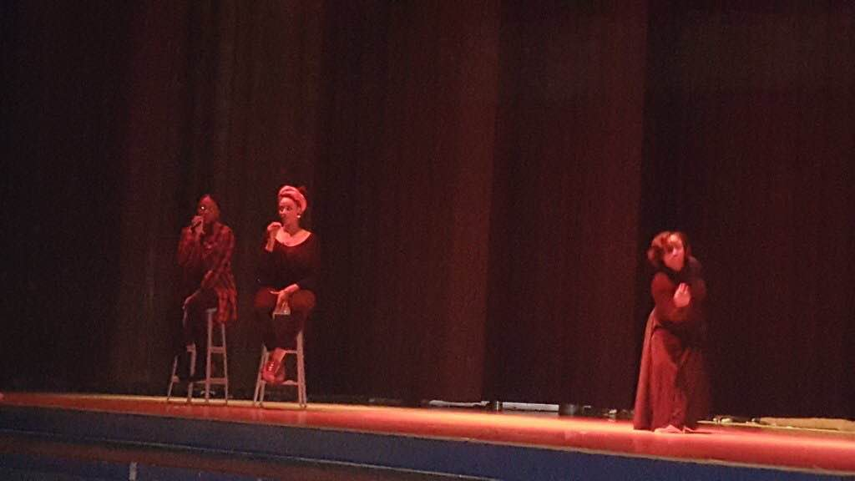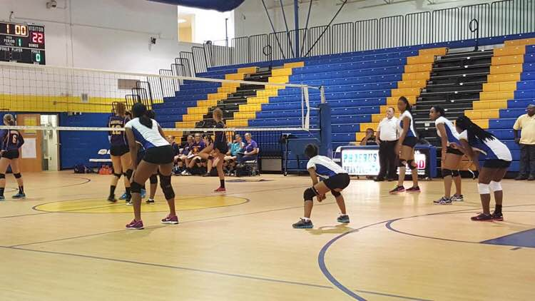

## Charlene Branham

# **ABout Me!**

**aspire to be an anesthesiologist**

* **Singing is my passion**
* **Very competitive when it comes to sports**
* **I’ve played soccer and volleyball**
* **I am also a self-taught artist**
* **Faith: Christian**
* **Addiction: online shopping**
* **Favorite colors are pink and green but not together.**
* **Est. in 98**
* **Family is where my heart is**
* **Love writing off of inspiration**