Old Dominion University/BIOL303-Genetics/Rinehart-Kim/Module 9/Romanov Project

You may use various Internet sources to answer any of the questions, but please cite any sources that you use if they are not ones that I suggest.

History

You may use various Internet sources here, but please cite any sources that you use (unless I have given it to you). You will be using the following source for another section in this assignment, but it might help you answer some of the questions in this section. If you use this source to answer the following questions, you do not need to cite it. [*http://journals.plos.org/plosone/article?id=10.1371/journal.pone.0004*](http://journals.plos.org/plosone/article?id=10.1371/journal.pone.0004)*838 (You should be able to access the entire article. You may need to copy and paste the site address.)*

1. Who were the Romanov’s (in Russian history)?

They were the last reigning royal family in Russia.

1. How long had the Romanovs been in power in Russia?

The Romanov’s ruled the country of Russia for over 300 years.

1. Nicholas II was the last Romanov to hold power in Russia. What was his title?

After the Bolshevik Revolution Nicholas II gave up his thrown. He tried to give it to his brother Grand Duke Michael, who declined. There then was a time of political unrest and unstable government. Eventually, Lenin returned and created the communist party.

1. What happened to Nicholas II? Why (from a geopolitical view)? Who then took control?

 After the Bolshevik revolution, Tsar Nicholas II gave up his thrown. He then attempted to give it to his brother the crown but was denied. Then there was a time of provisional government for a time that was unstable. Eventually, Lenin took control and created the communist party in Russia.

1. Describe the family of Nicholas II. What happened to them?

The royal family consisted of Nicholas and his family - his wife, the Tsarina Alexandra, and their five children: Olga, Tatiana, Maria, Anastasia, and the Tsarevich (Crown Prince) Alexei. They were were held in exile in Yekaterinburg, Russia. After a failed rescue attempt from the Russian White Army, the Ural Soviets decided to execute the entire family.

6 One of the reasons that the family of Nicholas II was executed was because there was a fear that the White Russian Army would save them. Who was the White Russian Army?

The Russian White Army was a counter protesting group fighting against the Bolshevik-controlled Red Army for the control of Russia.

Source: <https://alphahistory.com/russianrevolution/white-armies/>

Hemophilia

The pedigree chart below comes from the Module powerpoint lecture notes.

1. How was Nicholas II wife, Alix, related to Queen Victoria of England?

She was the granddaughter of Queen Victoria

Both Queen Victoria and Alix are designated as being carriers for hemophilia.

1. In a couple of sentences, describe the disease hemophilia.

Hemophilia is a disease that decreases the ability of blood clotting. Hemophilia is caused by a mutation or change, in one of the genes, that provides instructions for making the clotting factor proteins needed to form a blood clot. This change or mutation can prevent the clotting protein from working properly or to be missing altogether. These genes are located on the X chromosome.

Source <https://www.cdc.gov/ncbddd/hemophilia/facts.html>

Use the following source for the questions 8 & 10: [*http://www.ncbi.nlm.nih.gov/pubmed/20557352*](http://www.ncbi.nlm.nih.gov/pubmed/20557352) *(You won’t be able to access the entire article, but the abstract will give you the information you need to answer the questions.)*

.

9. What type of hemophilia (A or B) is (probably) represented in the pedigree chart?

We can conclude that hemophilia B is what’s represented on the pedigree chart due to the research done on the Romanov’s remains.

10. Using your knowledge from Module 4, on what chromosome is the gene that causes hemophilia?

The gene that causes hemophilia is located on the X chromosome

11. Describe the mutation that apparently caused hemophilia in Alix, (and probably all of the European families that had hemophilia).

According to the NCBI article this mutation that apparently caused hemophilia in Alix was a substitution mutation on exon 4, gene F9. A substitution mutation works in such a way that one nitrogenous base is swapped for a different one.

12. Using your knowledge from Module 7, describe how the mutation you described in #10 could result in a faulty gene product.

Based upon what I’ve learned in module 7, the mutation described in the previous question was a substitution mutation. This type of mutation causes faulty product would meaning it would have to code for a different amino acid, thus creating a different protein. It is most likely that this base was not the third one in the codon because due to the wobble principle, a change in the third base pair would most likely result in a silent mutation. Knowing this information, it is easy to believe that this substitution was most likely on the first or second base of a codon, and synthesized a new amino acid and eventually a new protein.

13. Again, using your knowledge from Module 4, give the genotype for a carrier of hemophilia.

The gene for a carrier of hemophilia is having an X chromosome.

14. The Romanov’s son, Alexis, had hemophilia. Describe how Alexis genetically acquired hemophilia. (Use a Punnett square. You can either draw a table or line up the genotypes.)

|  |  |  |
| --- | --- | --- |
|  | XH | Y |
| XH | XHXH | XHY |
| Xh | XHXh | XhY |

15. Using a Punnett square (again, draw a table or line up the genotypes), explain why only males in the pedigree

chart have hemophilia. (Choose at least one of the males represented in the pedigree chart, and show his parents in the Punnett square.)

|  |  |  |
| --- | --- | --- |
|  | XH | Y |
| XH | XHXh | XHY |
| Xh | XHXh | XhY |

Only males in the pedigree have hemophilia because statistically, they are more likely to be a recipient than females.

16. Is it possible for a female to inherit hemophilia, and, if so, how?

Yes, it is possible for females to inherit hemophilia, it is just very rare due to it being an X-linked disease. In order for a female to inherit it both parents would have to be carriers for the disease.

17. Using a Punnett square (again, draw a table or line up the genotypes), what is the probability the daughter of a mother who is a carrier and a father who does not have the disease, will be a carrier?

|  |  |  |
| --- | --- | --- |
|  | XH | Y |
| XH | XHXH | XHY |
| Xh | XHXh | XhY |

The possibility would be ¼.

18. Using a Punnett square (again, draw a table or line up the genotypes), what is the probability that 4 daughters of a mother who is a carrier and a father who does not have the disease, will be a carrier?

|  |  |  |
| --- | --- | --- |
|  | XH | Y |
| XH | XHXH | XHY |
| Xh | XHXh | XhY |

The probability of having a daughter that will be a carrier for the disease is about ½ . The probability having 4 daughters, all being carriers, is about 1/16 .

19. Using a Punnett square (again, draw a table or line up the genotypes), explain why none of Alexi’s sisters had hemophilia.

|  |  |  |
| --- | --- | --- |
|  | XH | Y |
| XH | XHXH | XHY |
| Xh | XHXh | XhY |

Being that Alexi’s mother was a carrier for hemophilia, and his father didn’t have the disease nor was he a carrier for it, all of his sisters would have been either heterozygous or homozygous dominant. If they were homozygous dominant then they would have neither had the disease nor been a carrier for it.

20. Some historians speculate that Alexis’ hemophilia condition could have led to the Russian Revolution. Explain. You probably want to look up the faith healer Rasputin.

Alexis was very sick, so naturally his father wanted to heal him. They then asked for the help of Rasputin, a faith healer. Rasputin essentially used his connections with Tsar Nicholas to influence many governmental affairs. In return, the Russian people could not stand this, leading many historians to believe that this could have lead to the Russian Revolution.

Source: <https://www.ncbi.nlm.nih.gov/pmc/articles/PMC2652717/>

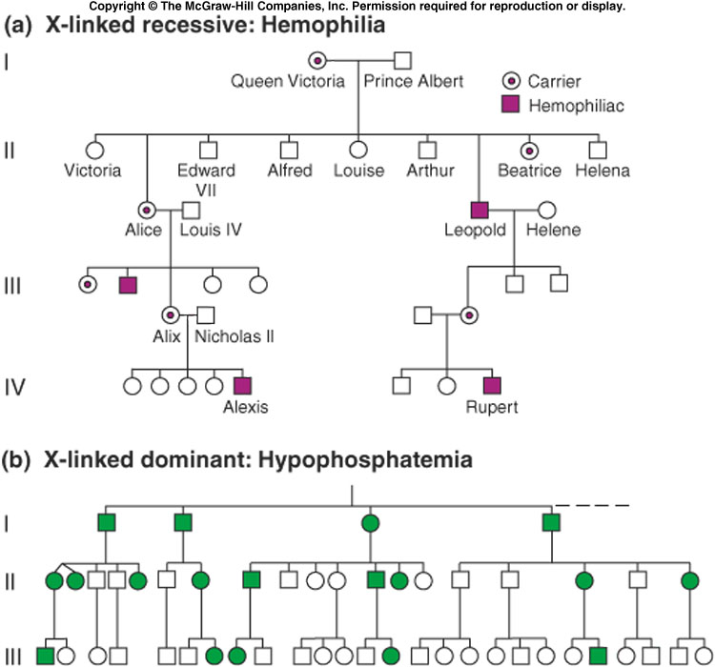

Molecular Analysis of People in a Mass Grave

Use the following source to help you answer the following questions: *http://journals.plos.org/plosone/article?id=10.1371/journal.pone.0004838 (You should be able to access the entire article.)*

21. Two “graves” were discovered near Yekaterinburg, Russia. Describe the number of bodies in each grave.

The larger grave had 9 bodies while the smaller grave had 2.

22. When were these graves discovered?

The graves were originally found in the late 1970s, but the official discovery of the bigger grave was in 1991. The smaller grave was officially discovered in the summer of 2007.

23. What type of testing was done to confirm sex and familial relationships among the remains found in the mass grave?

 Nuclear DNA testing of five STR markers was used to confirm the sex of the skeletons and to establish a familial relationship among the remains found in the larger grave.

24. Genetically, what does STR “stand” for?

 STR in genetics stands for Short Tandem Repeat. A short tandem repeat is a microsatellite, consisting of a unit of two to thirteen nucleotides repeated hundreds of times in a row on the DNA strand.

Source: <https://www.ncbi.nlm.nih.gov/pmc/articles/PMC4509031/>

25. Mitochondrial DNA testing was also done on both Nicholas II and Alix. Why was information from Alix’s, but not Nicholas’, mitochondrial DNA used to identify three females as belonging to Alix?

 Mitochondrial DNA is inherited from mother, but not from the father. By knowing this fact, mitochondrial DNA is maternally inherited is used to trace maternal lineage.

26. HRH Prince Philip, the Duke of Edinburgh, provided mitochondrial DNA used to identify Alix and her three daughters.

Why was his mitochondrial DNA used?

Who is the HRH Prince Philip, the Duke of Edinburgh in today’s world? Do you ever hear of his grandchildren or great-grandchildren (in *People* magazine while you are waiting to check out of a store)?

Prince Phillip is the husband to Queen Elizabeth the 2nd, we hear about his grandchild Prince Harry in the news all the time, especially since he’s married Megan Markle and separated from the royal family. HRH Prince Philip and Alix all share the same maternal lineage as they are all descendants of Queen Victoria, so all of them share the same mitochondrial DNA. Since they share mitochondrial DNA his DNA could be used to identify the daughters of Alix.

27. Who was missing from the mass grave?

Prior to 2007, two children were thought to be missing from the grave. One was Alexei, who was later identified, and one of his sisters.

28. The Duke of Fife and Princess Xenia provided mitochondrial DNA used to identify Nicholas. One of these is a female and another is a male. Does that matter? What general statement can you make about their genetic

relationship to Nicholas and Alexandra?

 Overall, yes, it does matter. In general the duke of Fifie and Princess Xenia would both have strong genetic relationships with Nicholas. However, only Princess Xenia would share mitochondrial DNA with Nicholas as children receive maternal mtDNA

 29. What was discovered in the mitochondrial DNA of Nicholas that was not identified in either the Duke of Fife or Princess Xenia?

They found a single point heteroplasmy (presence of more than 1 mtDNA genome in a cell) at position 16169 (C/T= “Y”). This differs from both the Duke of Fife and Princess Xenia as they were, according to this source, “fixed for 16169 T”

30. What is the term given to the existence of two (or more) genetically different mitochondria in the cell?

The term for two or more genetically different mitochondria in the cell is heteroplasty.

31. What three types of DNA were used to test the remains found in a second grave?

* Mitochondrial DNA (mt DNA)
* Autosomal DNA used in autosomal STR testing
* DNA   present as short tandem repeat (STR) on the Y-chromosome

32. Of the three types of DNA you listed in #32, which one would have been used specifically to identify Alexis?

Y-Str testing was applied directly to Alexis.

33. What was the source of the DNA used to identify Alexis?

To identify the source of the DNA of Alexis, Y-STR testing on the skeletal material has been carried out. DNA samples were taken from Tsar Nicholas and one of his distantly related cousins Prince Andrew Andreevich Romanov.

34. Was Anastasia in the grave in which Alexis was found?

It was never conclusively established that Anastasia was found.

Who Wants to Be Anastasia?

Apparently, about 200 people have wanted to be Anastasia and have claimed to be her! One of the most famous imposters was a woman named Anna Anderson (Manahan).

Refer to the following source to help you answer some of the following questions: <http://www.nature.com.proxy.lib.odu.edu/ng/journal/v9/n1/pdf/ng0195-9.pdf> (Please note that this is a PDF of the article and is provided via the ODU Library.)

35. Give a brief history (2-3 sentences) of Anna Anderson-both her claims and what is thought to be true.

Anna Anderson was one of the many imposters who claimed to be Anastasia. It was claimed that she had escaped firing squad by Bolshevik firing squad on July 16th 1918. DNA from her hair was examined, and it was concluded not to match maternal DNA of Tsarina or HRH Prince Phillip.

36. Where in the US did Anna Anderson eventually settle?

She settled in Charlottesville, VA.

Source: https://www.legacy.com/news/anna-anderson-the-great-imposter/

37. Whom did she eventually marry?

She married J. E. Manahan, a history professor.

Source: <http://www.legacy.com/news/explore-history/article/anna-anderson-the-great-imposter>

38. What were the sources of Anna Andersons’s nuclear DNA?

They used strands of her hair and intestine samples.

39. What were the sources of Nicholas’ and Alix’s nuclear DNA?

The sources of Nicholas’ and Alix’s nuclear DNA were skeletal, bone, samples.

40. What type of analysis was done on DNA from Anna Anderson, Nicholas, and Alix?

Both mtDNA and STR analysis were done on all three.

41. Anna Anderson’s mitochondrial DNA was compared to the mitochondrial DNA of what two people?

Anna’s mtDNA was compared to Carl Maucher’s and Duke of Edinburgh, who was the great nephew of Tsarina.

42. A hypervariable region of the mitochondrial DNA was analyzed. Define a hypervariable region?

“Hypervariable sites in human mtDNA are readily identified in evolutionary studies and are usually assumed to represent mutational hotspots. Recently, an alternative hypothesis was proposed that holds that hypervariable sites may instead reflect ancient mtDNA mutations that have been “shuffled” among different lineages via recombination.”

Source: <https://www.ncbi.nlm.nih.gov/pmc/articles/PMC1287875/>

43. What were the conclusions from the mitochondrial DNA comparisons?

It was concluded that Anna was not related to the Romanovs.

44. The article which describes the analysis of Anna Anderson’s DNA was published in 1995.

When were all of Nicholas’ and Alix’s children finally accounted for?

All children were accounted for in 2007, although they are unsure which remains belong to who between Anastasia and Maria.

45. Before doing this assignment, what did you already know about the last Tsar of Russia and his daughter Anastasia. What did you learn from doing this assignment?

Before doing this assignment, I knew nothing about the Tsar of Russia or his daughter Anastasia. I learned an abundance about how DNA lineages can be traced through various methods.

Are you still interested in the life of the last Tsar of Russia and his relationship to British royalty? The headline for the following article showed up on my Internet browser recently. While I can’t vouch for it as it did not appear in a peer-reviewed journal, it might be interesting reading for some of you.

<https://www.townandcountrymag.com/society/tradition/a31028924/windsors-romanovs-relationship-last-gathering-true-story/>