Amajah R Goode

01131321

Old Dominion University/BIOL303-Genetics/Rinehart-Kim/Module 9/Romanov Project

You may use various Internet sources to answer any of the questions, but please cite any sources that you use if they are not ones that I suggest.

Part II: Hemophilia

The pedigree chart below comes from the Module powerpoint lecture notes.

Use the following source for the questions 2: [*http://www.ncbi.nlm.nih.gov/pubmed/20557352*](http://www.ncbi.nlm.nih.gov/pubmed/20557352) *(You won’t be able to access the entire article, but the abstract will give you the information you need to answer the questions.)*

1. Using your knowledge from Module 4, on what chromosome is the gene that causes hemophilia? **As a result of a mutation of the X-chromosome, hemophilia is a disease caused by damage to the X gene.**

2. Describe the mutation that apparently caused hemophilia in Alix, (and probably all of the European families that had hemophilia). **A mutation occurred in exon 4 of the F9 gene which substituted the splice acceptor site. Substitution mutations occur when nitrogenous bases are substituted and amino acid sequences are altered.**

3. Using your knowledge from Module 7, describe how the mutation you described in #10 could result in a faulty gene product. **As a result of a mutation, a person loses one of the clotting factors that prevents blood from clotting nonstop. A gene mutation, for example, can lead to hemophilia due to a missing gene being inserted into another gene. Alternatively, if I only had one apple and I need two to make a full pie, I will be limited to making a half pie. As a result of hemophilia, this happened. The proper clotting cannot be achieved without factor VIII or XI.**

4. Again, using your knowledge from Module 4, give the genotype for a carrier of hemophilia.

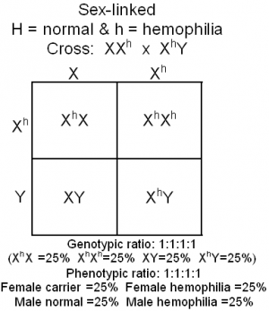

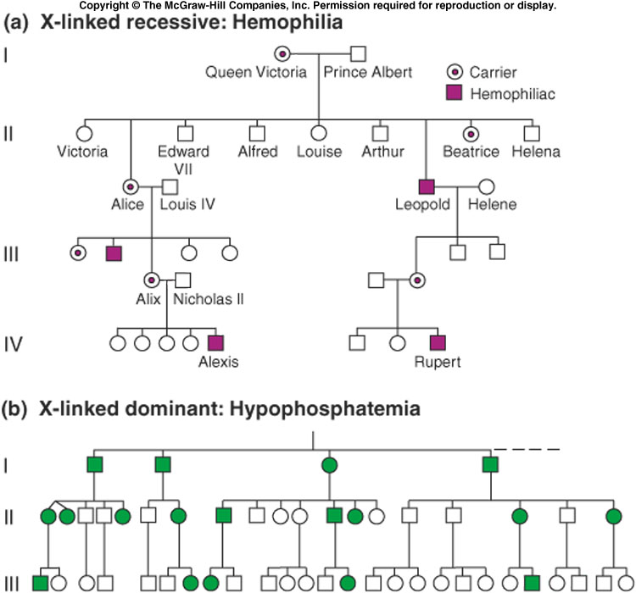

Part III: Molecular Analysis of People in a Mass Grave

Use the following source to help you answer the following questions: *http://journals.plos.org/plosone/article?id=10.1371/journal.pone.0004838 (You should be able to access the entire article.)*

5. Mitochondrial DNA testing was also done on both Nicholas II and Alix. Why was information from Alix’s, but not Nicholas’, mitochondrial DNA used to identify three females as belonging to Alix? **Alix's mtDNA is more suitable for identification of the three females because mtDNA is passed unchanged from mother to daughter, while males do not pass on mtDNA.**

6. HRH Prince Philip, the Duke of Edinburgh, provided mitochondrial DNA used to identify Alix and her three daughters.

Why was his mitochondrial DNA used?

Who was the HRH Prince Philip, the Duke of Edinburgh in today’s world? Do you ever hear of his grandchildren (in magazines while you are waiting to check out of a store)? **A comparison and solidification of mtDNA with Tsarina Alexandra was done using Prince Philip who was the only living relative of Tsarina Alexandra. In addition to confirming the mtDNA between the two, the three daughters also shared the same mtDNA.**

7. Who was missing from the mass grave? **The second grave contained bones of Tsarevich Alexei and one of his sisters, which were identified as male and female.**

8. The Duke of Fife and Princess Xenia provided mitochondrial DNA used to identify Nicholas. One of these is a female and another is a male. Does that matter? **What general statement can you make about their genetic**

**relationship to Nicholas. If the parents are being identified, using a male and female mtDNA is important. However, comparing the mtDNA is not necessary.  It is very important to demonstrate that the lineage of the mtDNA of a family originates from a genetic female or matriarch of the family. Their mtDNA links to Nicholas II, showing they are maternal cousins to the Duke of Fife and Princess Xenia.**

9. What was discovered in the mitochondrial DNA of Nicholas that was not identified in either the Duke of Fife or Princess Xenia? **It was found that the single point of heteroplasmy at 16169 was different depending on the ratio of C to T. Tsar Nicholas ratio was C/T.**

10. What is the term given to the existence of two (or more) genetically different mitochondria in the cell?

**Heteroplasmy**