CYSE 301: Cybersecurity Technique and Operations
Assignment 2: Traffic Tracing and Sniffing
Task A
Q1. How many packets are captured in total? How many packets are displayed?
127 packets were captured in total. 127 packets are displayed.
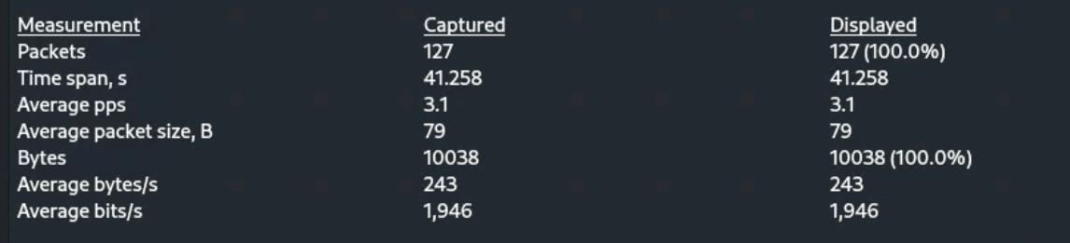
Q2. Apply “ICMP” as a display filter in Wireshark. Then repeat the previous question (Q1).
84 packets were captured. 84 packets are displayed.
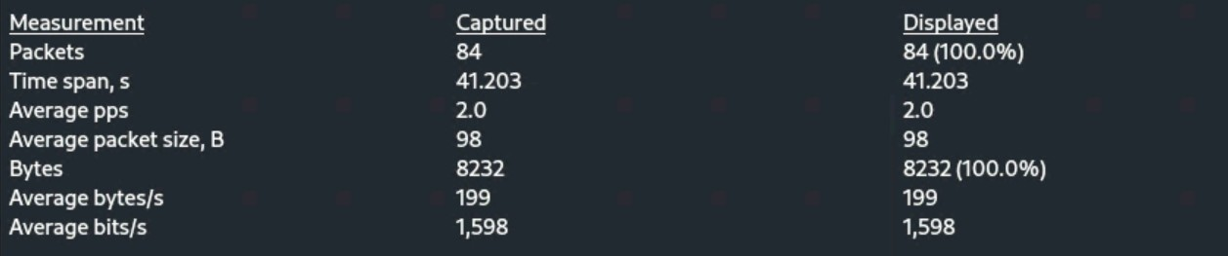
Q3. Select an Echo (replay) message from the list. What are the source and destination IPs of this packet? What are the sequence number and the size of the data? What is the response time?
Source IP – 192.168:10.18
Destination IP – 192.168.217.3
Sequence number – 17667
Size of data – 40 bytes
Response time – 2.316 ms
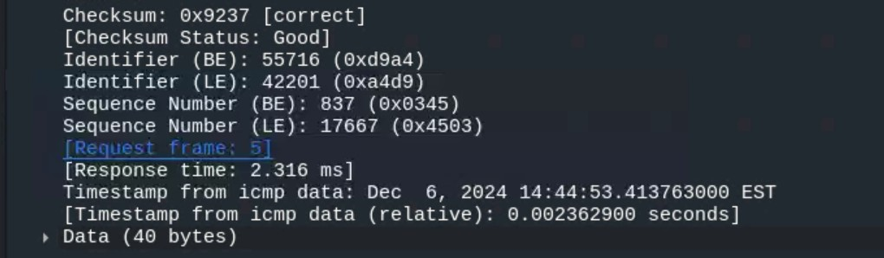
Q4. Apply “DNS” as a display filter in Wireshark. How many packets are displayed?
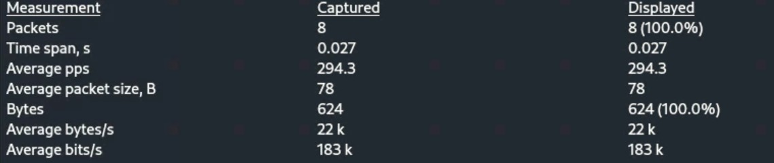
Q5. Find a DNS query packet. What is the domain name this host is trying to resolve? What is the source IP and port number, destination IP and port number? Please express in the format: IP:port.
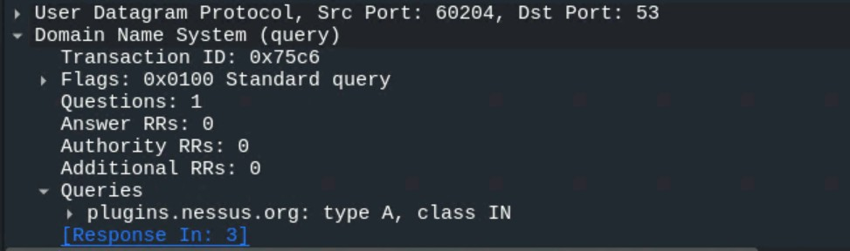
Domain name – plugins.nessus.org
Source IP:port = 192.168.217.3:60204
Destination IP:port = 192.168.217.2:53
Q6. Find the corresponding DNS response to the query you selected at the previous step, and what is the source IP and port number, destination IP and port number? What is the message replied from the DNS server?
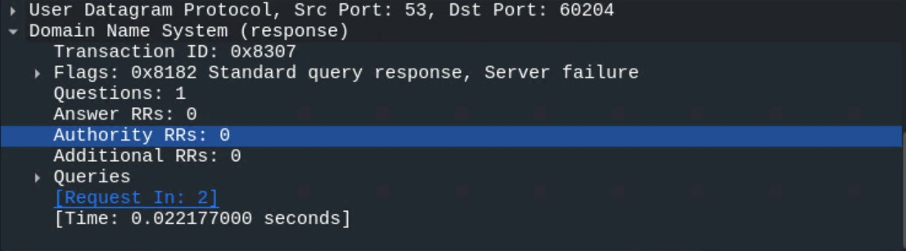
Source IP:port = 192.168.217.2:53
Destination IP:port = 192.168.217.3:60204
Message - Standard query response, Server failure
Task B
1. Sniff ICMP traffic (10 + 10 = 20 points) Open two terminals on External Kali VM. Use one ping Ubuntu VM, and use the other ping Internal Kali.
- Apply proper display or capture filter on Internal Kali VM to show active ICMP traffic.
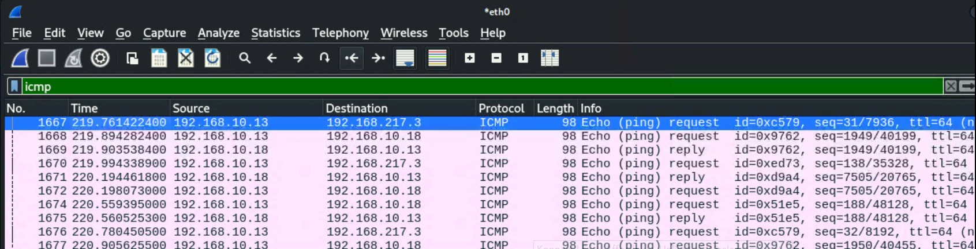
- Apply a proper display or capture filter on the internal Kali VM that ONLY displays the
ICMP request that originated from the external Kali VM and goes to the Ubuntu 64-bit VM.
2a Ubuntu VM is also serving as an FTP server inside the LAN network. Now, you need to use External Kali to access this FTP server by using the command: ftp [ip_addr of ubuntu VM]. The username for the FTP server is cyse301, and the password is password. You can follow the steps below to access the FTP server.
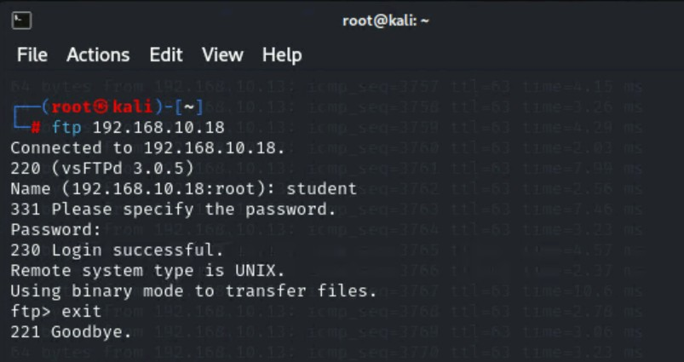
- Unfortunately, Internal Kali, the attacker, is also sniffing into the communication. Therefore, all of your communication is exposed to the attacker. Now, you need to find out the password used by External Kali to access the FTP server from the intercepted traffic on Internal Kali. You need to take a screenshot and explain how you found the password.
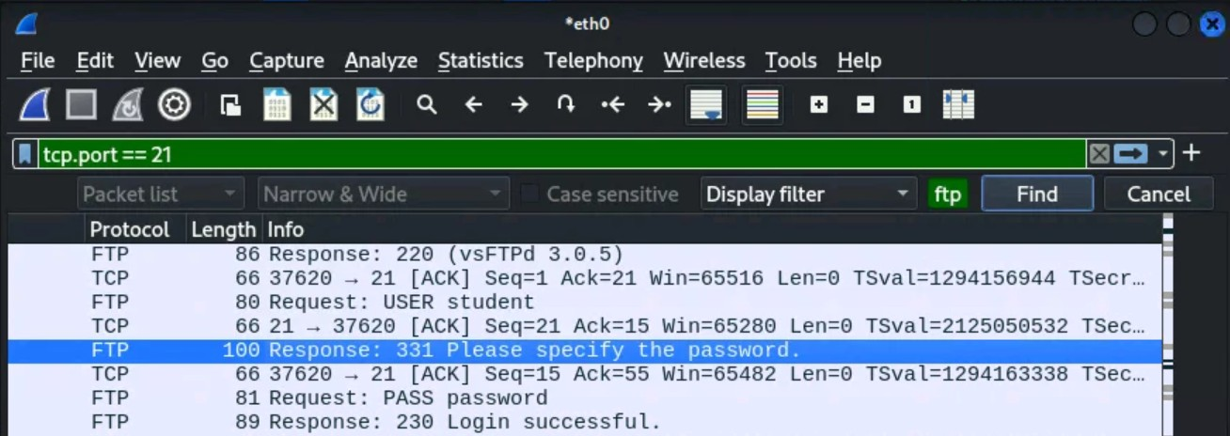
To find the password used by External Kali to access the FTP server, I captured the network traffic on Internal Kali using Wireshark. I filtered the traffic using the ftp filter to isolate the FTP communication. In the captured packets, I looked for the FTP USER and PASS commands. The password was visible in clear text within the PASS command, which I located in the packet details. Since FTP transmits credentials in an unencrypted form, the password (password) was easily identifiable in the captured traffic.
- After you successfully find the username & password from the FTP traffic, repeat the previous step (2.a), and use your MIDAS ID as the username and UIN as the password to reaccess the FTP server from External Kali. Although External Kali may not access the FTP server, you need to intercept the packets containing these “secrets” from the attacker VM, which is Internal Kali.
