CYSE 301: Cybersecurity Technique and Operations
Assignment 5: Password Cracking (Part A)

Task A: Linux Password Cracking
- Create two groups, one is cyse301, and the other is your ODU Midas ID (for example, svatsa). Then display the corresponding group IDs.
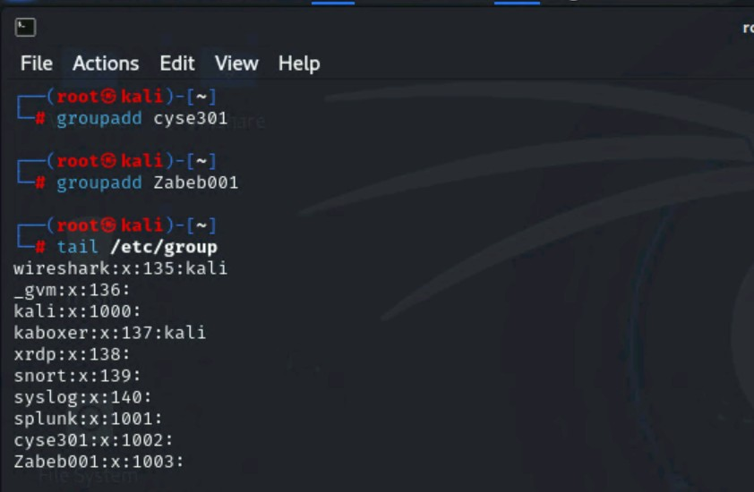
- Create and assign three users to each group. Display related UID and GID information of each user.
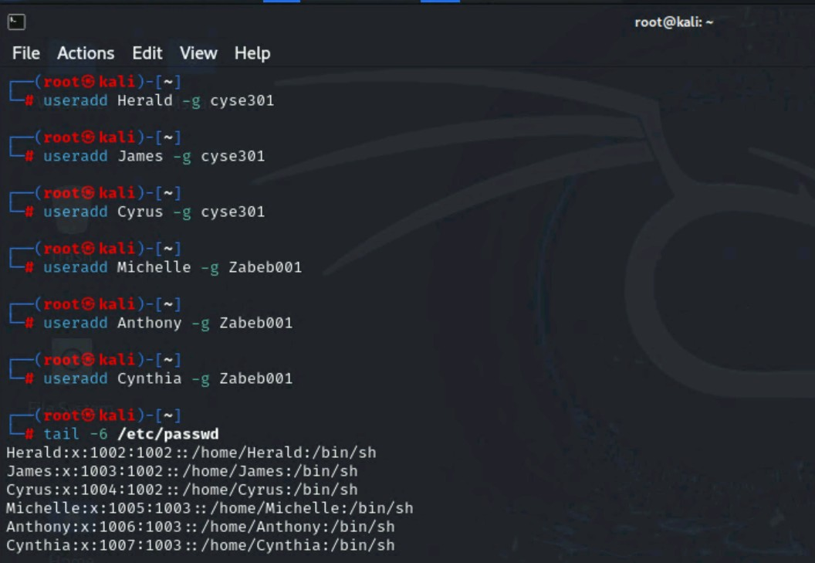
- Choose Three new passwords, from easy to hard, and assign them to the users you created. You need to show me the password you selected in your report, and DO NOT use your real-world passwords.
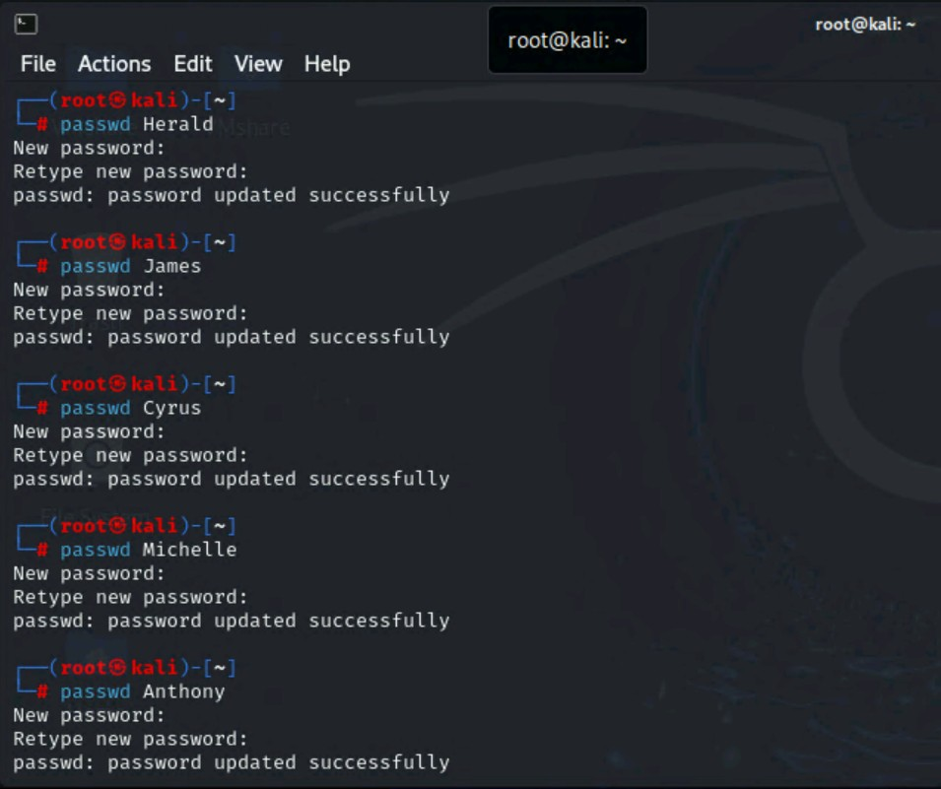
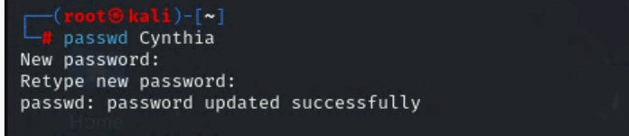
- Export all Three users’ password hashes into a file named “YourMIDAS-HASH” (for example, svatsa-HASH). Then launch a dictionary attack to crack the passwords. You MUST crack at least one password in order to complete this assignment.
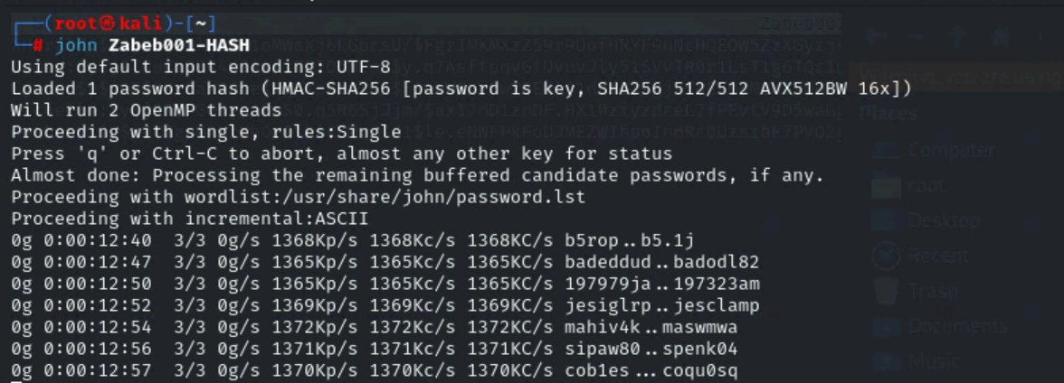

Task B: Windows Password Cracking
Log on to Windows 7 VM and establish a reverse shell connection with the admin privilege to the target Windows 7 VM
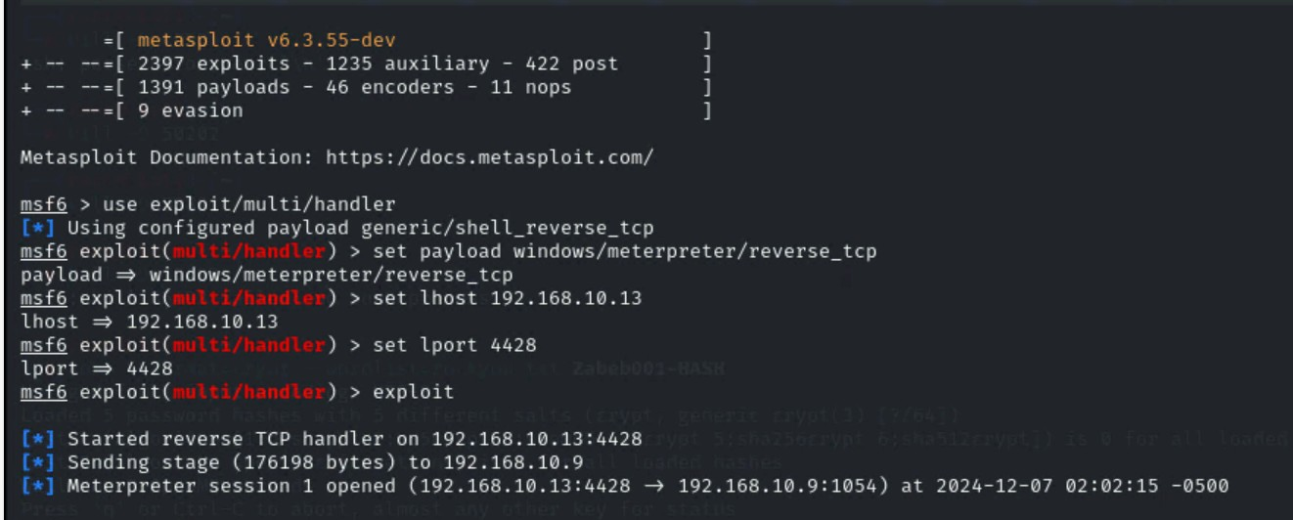
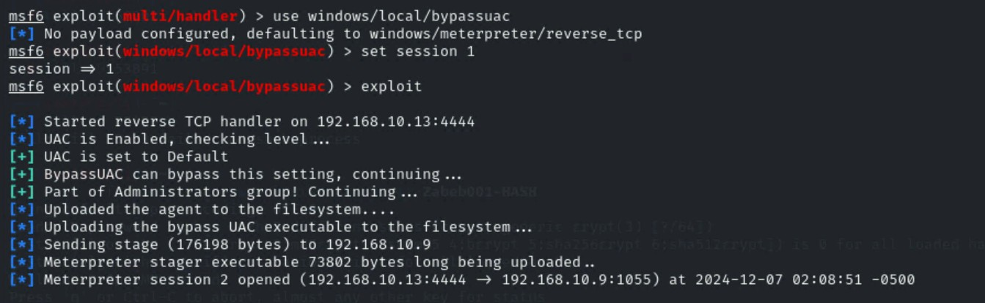
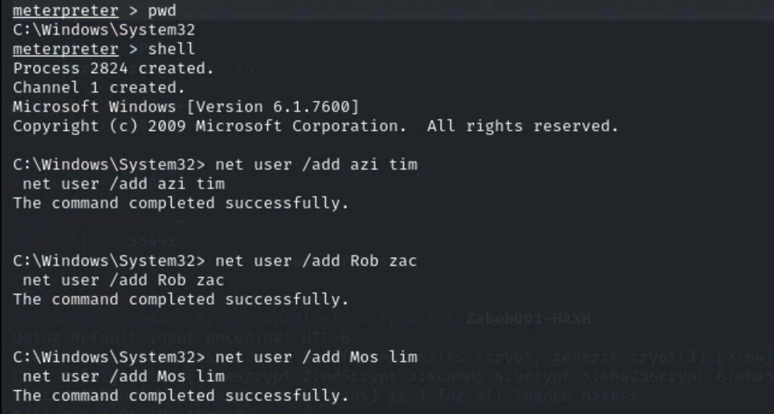
- Display the password hashes by using the “hashdump” command in the meterpreter she
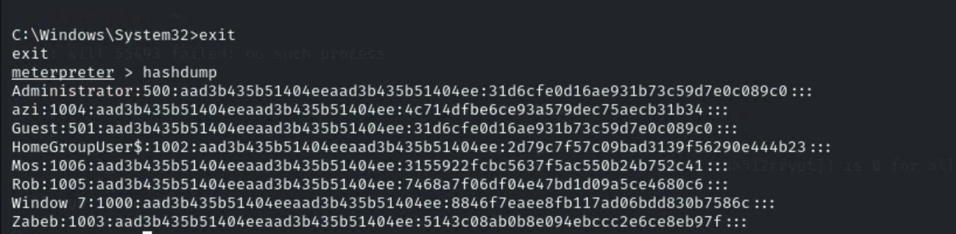
- Save the password hashes into a file named “your_midas.WinHASH” in Kali Linux (you need to replace the “your_midas” with your university MIDAS). Then run John the ripper for 10 minutes to crack the passwords (You MUST crack at least one password in order to complete this assignment.).
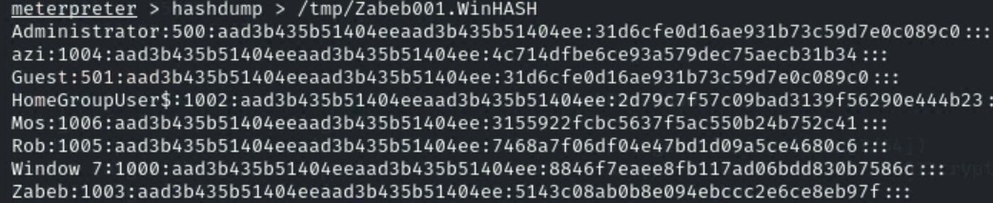
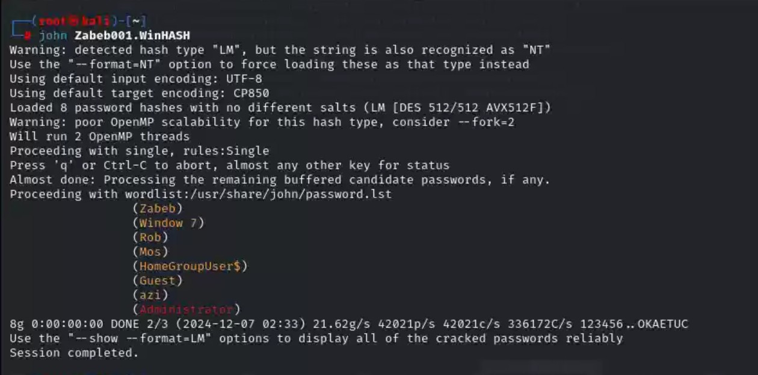
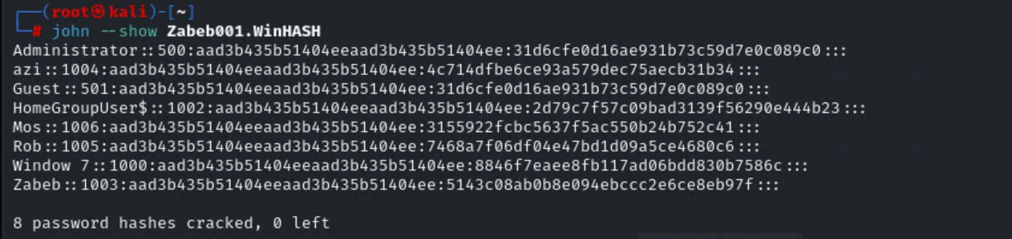

Task C
- Decrypt the lab5wep-demo. cap file (5 points) and perform a detailed traffic analysis (5 points)
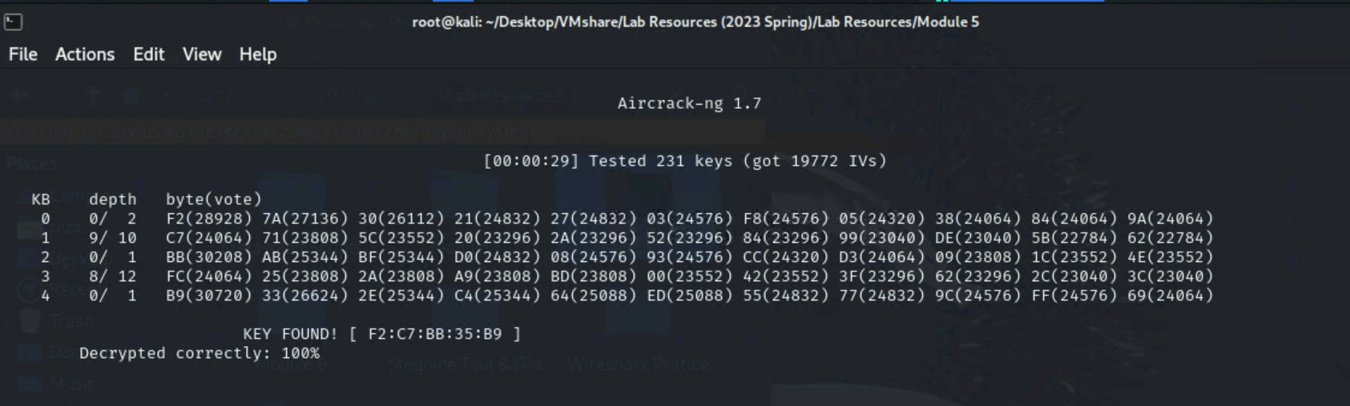
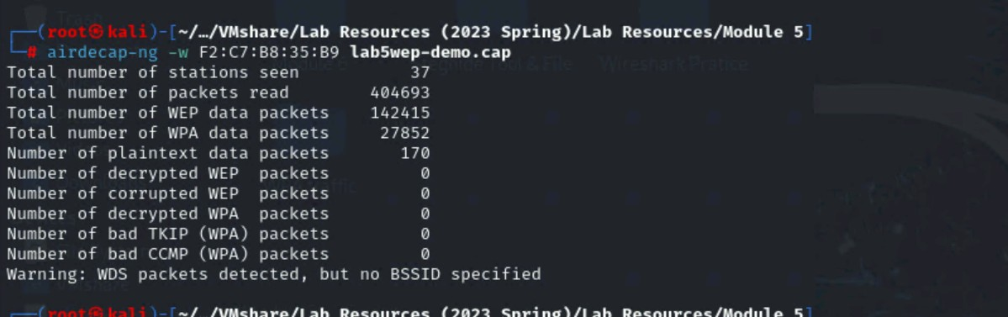
- Decrypt the lab5wpa2-demo. cap file (5 points) and perform a detailed traffic analysis (5 points)
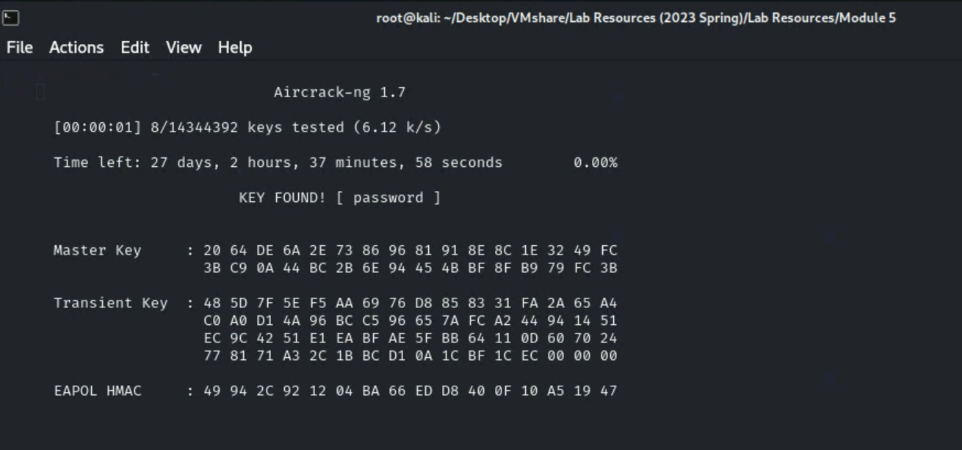
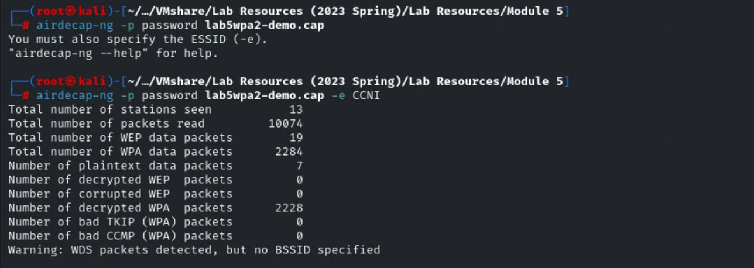

Task D
Implement a dictionary attack and decrypt the traffic using the correct file based on your last character of md5 hash for your midas name. - 20 points
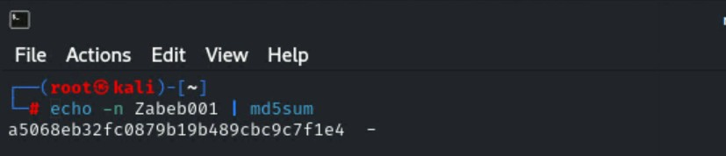
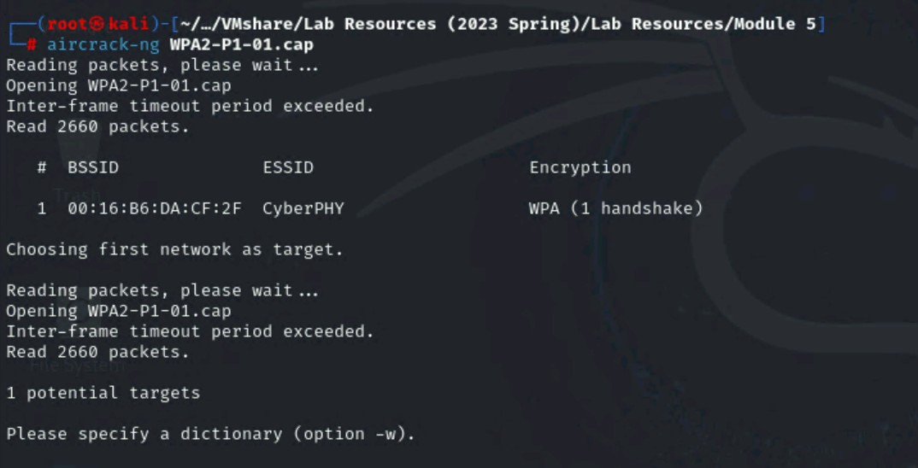
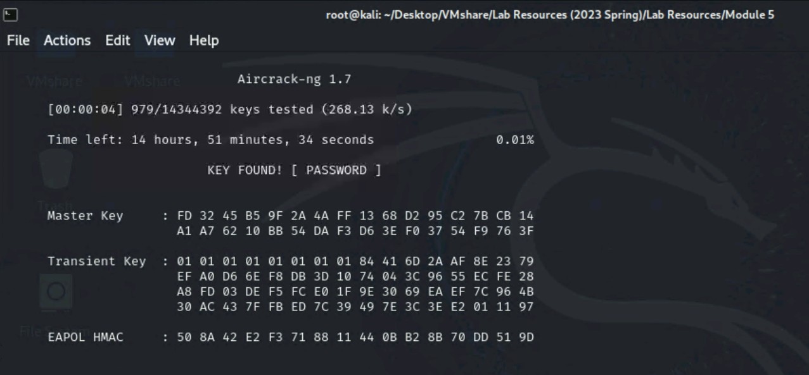
Decrypt the encrypted traffic and write a detailed summary to describe what you have explored from this encrypted traffic file (using wireshark). -10 points
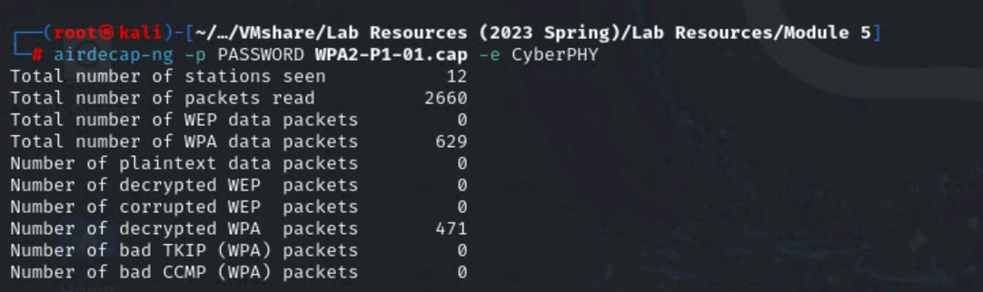
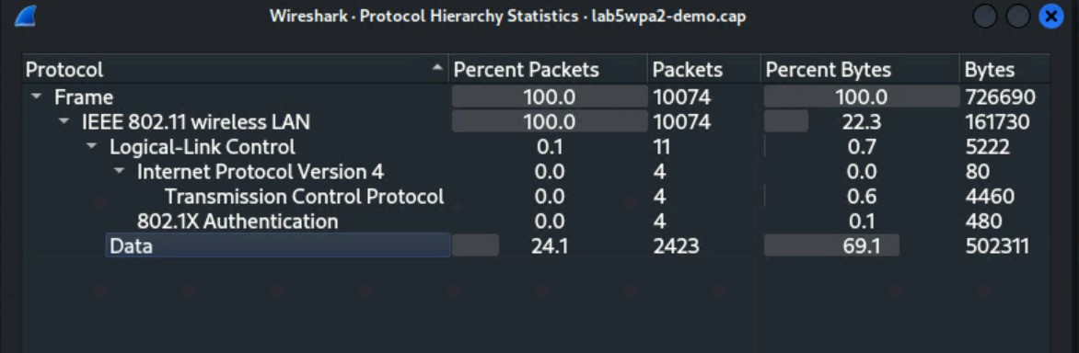
Once I decrypted the traffic in Wireshark, I used filters such as eapol and http to filter the packets that were captured so that I could gain some understanding of the network. By employing the eapol filter, I was able to see that it captured WPA2 handshake packets, thus the right phase of authentication for decryption. The http filter presented several HTTP request and response packet, which suggest users visiting websites or communicating with web servers. DNS packet analysis revealed that devices are doing name resolution and querying nameservers to resolve domain names to IP addresses. I also noted UDP traffic with service discovery protocols such as SSDP and NetBIOS, which means devices are sharing information on the local network. Of the observed traffic, most seemed to be regular traffic, but the use of unencrypted HTTP suggested security threats; however, no attacks or unauthorized access occurred. This allowed for analysis of the network traffic, regular traffic and some of the weaknesses for example use of HTTP instead of HTTPS.

